Security and Threat Risk Assessment Intake Form
STRA #: Click or tap here to enter text.
Purpose:
Security Threat and Risk Assessments (STRA) are conducted to evaluate the security threats and risks to government information, program, systems, and services. STRAs form a part of risk management process to ensure responsible management and security of information and information resources.
Instructions:
Please complete STRA intake form, refer to the STRA page for more information. Once complete submit intake form to NRM.InfoSecurity@gov.bc.ca
Section 1. Contact Information
Name: Joanna Wand | Position Title: Superintendent Predictive Services
Email: Joanna.wand@gov.bc.ca | Branch and Division:  BC Wildfire Service |  | Telephone:  250-318-2592
Other Contacts: (if applicable)
Business Owner: | Click or tap here to enter text. | Business Analyst: | Click or tap here to enter text.
Expense Authority: | Robert Warner | Technical Analyst: | Click or tap here to enter text.
Project Manager: | Joanna Wand

Section 2. System Information
System Name: Wildfire Predictive Services Web Application
Why is an STRA being initiated?  New Project  If Other please explain: Click or tap here to enter text. | Is this a web application?  ☒Yes ☐No
 | If a web application, has a vulnerability scan been done? Choose an item.
System Description: (provide a brief description of what is being assessed. Attach any security documentation that is available)
Wildfire PSU Web Application is currently a single page application for multiple products. It uses Keycloak for authentication purposes where required. It also uses its own API to interact with both government and external APIs to retrieve and send datasets.
Section 3. Technology Information
What type(s) of technology solutions are being considered? |  | Describe the technology stack of this system. (if applicable)  Click or tap here to enter text.
  Infrastructure | Choose an item.
  Software | Locally Developed
For cloud/SaaS solutions, has a legal review been conducted on the terms of service of the cloud/SaaS application? (SaaS solutions’ terms of service must comply to relevant laws in BC, for example the Attorney General Act of BC. A legal review must be completed prior to proceeding with the STRA process)
Choose an item.
Attach technical diagrams (architecture, deployment, topology, etc.) below:
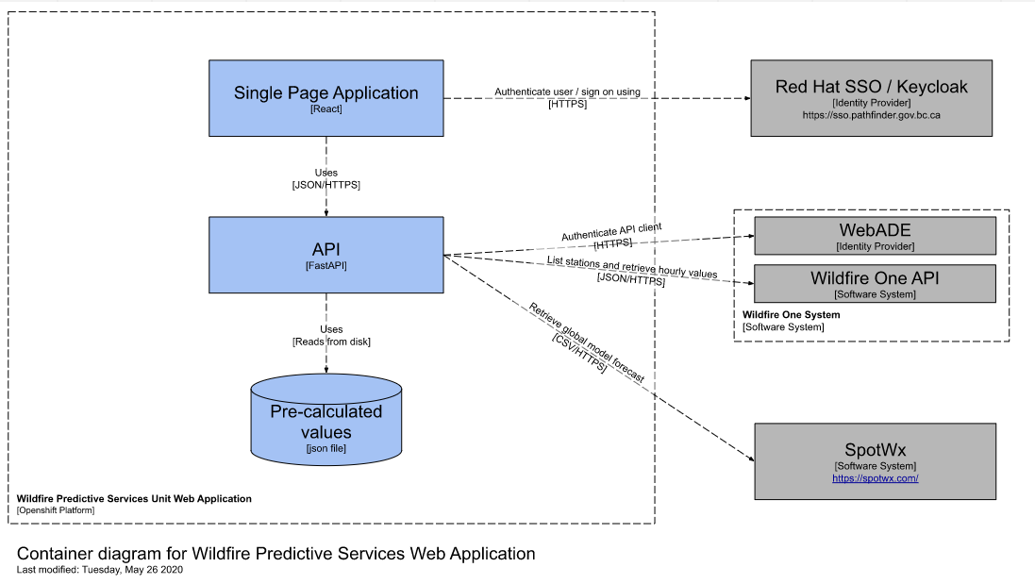

Security and Threat Risk Assessment Intake Form
Section 4. Criticality Assessment
What is the maximum level of harm that the business could suffer if key information held in, processed, or transmitted by the information resource were to be accidentally or deliberately: (refer to the Harm Table in appendix for additional info)
1. | Confidentiality - Disclosed to the wrong people |  |  | Choose an item.
2. | Integrity – Falsified or otherwise corrupted |  |  | Choose an item.
3. | Availability - Rendered unavailable for |  |  | Choose an item. | Choose an item.
Describe the potential impact if the maximum level of harm is realized: |  |  |  | Click or tap here to enter text.
Does the system contain Personally Identifiable Information (PII)? |  |  |  | Choose an item.
Has data security classification been conducted on the system?  Choose an item. |  |  |  | What is the highest security classification of data in the system? (Check one)  See Information Security Classification Standard for definitions.  ☐ Public ☐ Protected A ☐ Protected B ☐ Protected C
What is the business area’s Risk Profile for this system? (refer to the Harm Table in appendix for additional info)
1. |  | Risk Capacity – What is the level of risk you can afford to take (financial consideration) |  | Choose an item.
2. |  | Risk Tolerance – what is the level of risk you prefer to take? (emotional consideration) |  | Choose an item.
3. |  | Risk Appetite – what is the level of risk you need to take? (strategic consideration) |  | Choose an item.
What are the data flows for this information system? (if you have a diagram, please submit it with this form.)
Click or tap here to enter text.

Has this system been identified a ‘Critical System’ as defined in the Critical Systems Standard? If yes please identify compliance target date
Choose an item.
Click or tap to enter a date.
Has a Privacy Impact Assessment (PIA) been done? |  |  |  | Choose an item.
 |  |  |  | Click or tap here to enter text.
Section 5. Attachments
Please list any attachments that are being submitted with this assessment. (Add or remove rows from the table as required)
 | Attachment Name |  | Description of Attachment
1.
2.
3.
Please submit completed form to:
NRM.InfoSecurity@gov.bc.ca

Internal (IIT) Use Only
Fast Track Approved? | Choose an item.
Fast Track Rationale | Click or tap here to enter text.

Appendix
Harm Table
The harm table is provided as a general guide when assessing the maximum level of harm that can occur when the Confidentiality, Integrity and Availability of the system is compromised. The worse case scenario should always be considered (absence of all controls). Assess the contingencies and mitigations that are, or will be, in place.
